Connecting a QL To A VGA Monitor
Until recently it wasn’t possible to use a VGA monitor with a QL (apart from connecting a QL to a TV or monitor with SCART input). Even when connected like that, video overscan usually resulted in the loss of a few characters of the left of the monitor mode display. These articles show how you can connect an LCD VGA monitor to a QL via a video format adaptor.
- Simple Video Scalar
www.js-technology.com manufactures this device, which allows SCART-RGB and standard SCART video type signals to be adapted to work with an analogue VGA monitor input. To connect a QL to a VGA monitor would require that you build a SCART lead for the QL to connect it to the Simple Video Scalar. See http://www.fruitcake.plus.com/Sinclair/Spectrum128/SCARTCable/Spectrum128SCARTCableQL.htm for an example cable.
The Simple Video Scalar converts interlaced video to progressive such that video can be displayed on screens with a VGA / PC input. It operates by a process called de-interlacing. Whereby it converts the interlaced picture of a TV broadcast, or video cassette or DVD, to produce a full "progressive" picture.
The Simple Video Scalar is compatible with both NTSC and PAL resolution of 480i and 576i outputs its progressive equivalent of 480p and 576p.
A special version of the Simple Video Scalar is available for a Sinclair QL, which compensates for the slight overscan of a QL video signal, where you lose the first two or three characters on the left fo the screen. This must be specified when ordering the device, which costs about 70 pounds, although was on offer at £59.95 at the time of writing (end of 2013).
An in-depth article about the Simple Video Scalar and the QL may be found in Quanta Magazine, Volume 28 Issue 4 (June/July 2011). Thearticle was written by Dr John Sim of JS Technology.
- CGA/EGA/YUV to VGA Arcade HD-Converter PCB (GBS-8220)
http://www.jammaboards.com/store/cga-ega-yuv-to-vga-arcade-hd-converter-pcb-gbs-8220-gbs-8220.html
This official Gonbes CGA/EGA/YUV to VGA Arcade HD-Converter PCB allows all types of RGB, EGA, VGA or YUV component signals to be up-converted and displayed on a 31KHz PC VGA monitor, TFT monitor, LCD display, or HD-TV with VGA connection. No need to set dip switches in order to figure out the specific input frequency as all inputs are detected automatically! A great alternative to purchasing a expensive, heavy CGA monitor. Use this converter with an existing computer monitor or install a lightweight LCD display. It costs $39.95 from Jammaboards website above.
Peter Scott wrote a short article in Quanta magazine Volume 27 Issue 6 (December 2010) about using this device for connecting a VGA monitor to a QL, after reading about it on a Spanish website - http://zonadepruebas.org/backup/modules/smartsection/item.php?itemid=1225
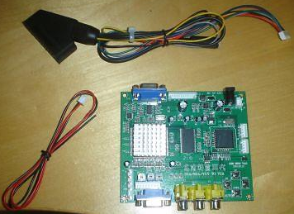
Peter wrote:
The board itself needs a 5 volt power supply with 2 amps minimum. I was lucky that I had a spare adaptor(Hama 46612) off an external floppy drive which was 5 volts at 2.5 amps. A 2 amp supply might be pushed a bit too much if left on a long time. The supply can be hard soldered to a separate input or there is a standard adaptor style socket, the center is positive polarity and the tip I used was 12mm long, 5mm wide with the inner part around 3mm. Next up for my cable I cut the scart end off a QL Scart cable which was wired as follows, with my cable viewed from the front, the wires were soldered to the supplied 8-pin RGB Cable and then individually insulated with tape. If all goes well, the screen will come up and you click the little menu button for your options which are initially in Chinese but it's easy just to flick through and find the English setting which the board remembers. You can also auto scan by holding down the auto button for 5 seconds and letting go. The quality is good although a little fuzzy around the lettering but this could be down to the sharpness settings and resolution of my old TFT monitor. Overall I was impressed and it's a great alternative to locking horns with old CRT monitors.
- 1080P SCART to HDMI Upscaler Converter – City Skys
This simple little black box takes a SCART RGB or HDMI input from most video sources and upscales it to a TV or monitor via an HDMI connection. All you need for connection is a QL RGB video to SCART lead to join it to the upscaler box and an ordinary HDMI lead to connect to the TV or monitor. When you switch everything on, there is a pause of a few seconds while it works out the signal types then suddenly the QL picture appears full screen. It handles PAL and NTSC, most resolutions, RGB or composite SCART video input or HDMI input from games machines etc, with HDMI output to 720p or 1080P.
I use mine with a 17 inch Technika kitchen TV which has both SCART and HDMI input, which allows me to compare both connection methods. A QL to SCART lead plugged into the TV provides a reasonable picture but as with so many systems, I lose a coupleof characters at the edge of the screen in QL monitor screen mode. But with an HDMI connection via the Upscaler, the QL monitor mode screen fills the Technika screen perfectly, all 85 characters across and the window borders visible. There are three front panel switches for manual selection of SCART or HDMI input, 720p or 1080p output, and PAL/NTSC 50/60Hz selection. In addition to the HDMI output there’s 3.5mm analogue audio and coaxial digital audio output. All this in a little black metal box some four inches square.
It also uses a standard 5Vdc 1A power supply via a 5mm/2.1mm connector (I think, it doesn’t specify, it looks like one of those). A UK Switch Mode PSU which has a 100-240V input range was supplied with the unit, but no HDMI cable, you can get those cheaply from places like Poundland in the UK. The picture quality obtained from the QL via the upscalar was good enough to allow the TV to be used as a QL monitor.
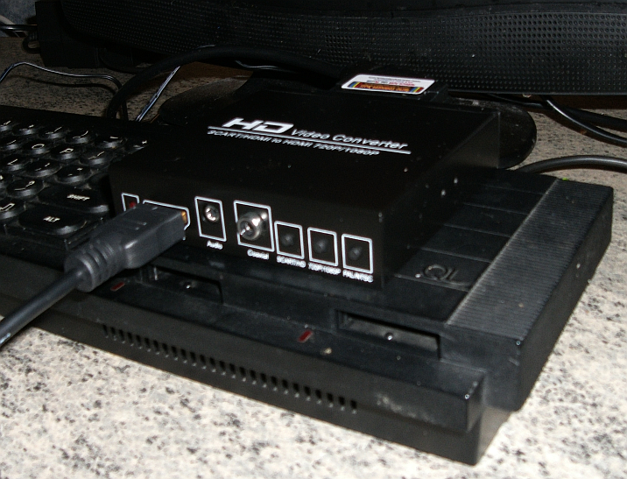
This device appears to be made in China and bears a website URL of http://www.hdmi-video.com/ .
The original was purchased from eBay, at the URL http://www.ebay.co.uk/itm/331100962220?ssPageName=STRK:MEWNX:IT&_trksid=p3984.m1497.l2649 and City Skys have an eBay store at http://stores.ebay.co.uk/city-skys/_i.html?_armrs=1&_dmd=1&_ipg=30&_sasi=1&_sop=1&_vc=1 which hosts a lot of similar gadgets. At the time of writing, this unit costs £38.95.

