
Internal Mouse·lnterface
For the Sinclair QL

WARNING
You must read the instructions through before installing QIMI in your QL: incorrect installation will probably damage your QL or QIMI or both. It may not be possible to fit QIMI to certain issues of the QL circuit board. If you are in any doubt, QIMI should be fitted by your QL dealer.
Dismantling your QL will void its warranty.
Although great care has been taken in the preparation of this product, QJUMP Ltd will not be liable for any direct, indirect or consequential damage or loss which may arise from any error, defect or failure of this product or the instructions.
Fitting QIMI
QIMI is an internal interface for the QL. To fit the interface, the QL case must be opened and two chips removed from the main board, these chips must be inserted into the interface and finally the interface inserted into the QL. Unfortunately, things seldom turn out to be as easy as they should. We have tried to simplify your problems by providing the tools that you will require. This interface has been fitted to a number of different versions of the QL including Samsung built US and German QLs.
Handling Static Sensitive Devices
The chips to be removed from the QL and the chips on the interface are "static sensitive". We handle these devices every day of the week without taking any special precautions. It is, however, very easy to destroy these devices with the levels of static that commonly occur in dry weather. The warning signs are getting crackly discharges from items like sweaters or getting shocks when you touch door handles, shake hands or kiss someone. You should have no problems if you avoid crackly clothing and areas with carpets which create shocks. It is best to sit down at a table to fit the interface, and not to get up until you have finished.
Surface Mount Devices
The QIMI interface uses the latest in surface mount technology.
The board itself is a very strange shape as it needs to miss all the odd bits on all QL board versions. This means that it can be fairly easily bent. Bending the board may cause the chips to become detached. This has not occurred on any of the most recent 100 or so interfaces, so we may now have removed this source of problems.
Preparation
When you try to remove the QL's case, you will find that considerable thought has been given to making maintenance difficult. In order to reduce the problems in reassembling the case, ensure that you have something to prop the lid (keyboard) against. If the lid falls over while you are fitting the interface, some of a group of six wires will probably be jerked out of their sockets. These wires have the interesting property that if you try to reinsert one of them, then another will come out. Inserting all six at once requires at least three (very small) hands.
Opening the QL
Turn the QL upside down and unscrew the 4 screws at the back of the case and the 4 screws on the front lip. Leave the 2 screws near the front underneath the Microdrives.
Holding the case together, turn the QL the right way up and facing you. Lift the front of the keyboard up and away from you. When it is vertical, ease the keyboard flexible "tails" (the flat stripy things) out of the two sockets. Rest the keyboard slightly beyond vertical behind the QL base.
Removing the QL ROM and ZX8302
The next thing to do is to examine the main board and locate the two chips to be removed. These chips are very close to the SER ports (see diagram).
The two chips are the upper ROM (marked QL.JM 8000 or QL.JS 8000 etc., or on early QLs, AH 4000 or JM 4000) and the ZX8302. There are a lot of other markings on these chips giving the manufacturer (usually VTI and NCR), the manufacturers type (usually 23128 and 0371725), the date of manufacture (e.g. 8532 - week 32, 1985) and batch identification.
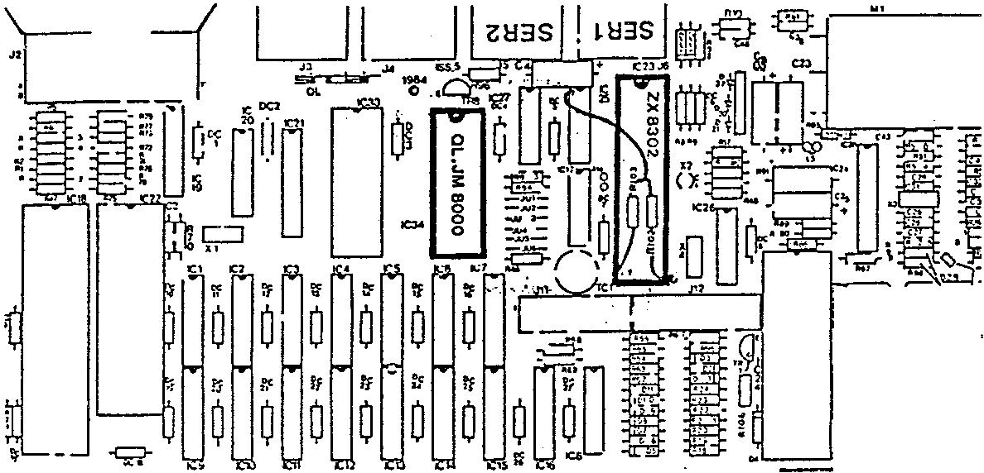
If your QL has a couple of little banded cylinders and bits of wire over the top of the ZX8302, this is mandatory modification "g". As this modification is very important in improving the reliability of the Microdrives, it has been incorporated onto the interface. The first thing you should do is to cut or break the wire and these "resistors" as close to the chip's legs as possible: wiggling the wires will usually do this quite well. Ensure that no bit of wire is left standing up.
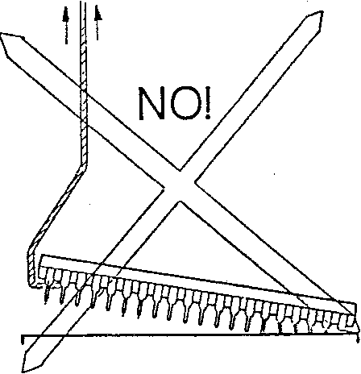
Next remove the two chips by easing out each end a little bit at a time. DO NOT try to pull one end out first, this is sure to bend the legs. DO use the flat extractor tool provided.
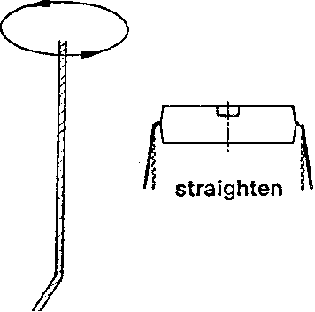

The legs of the two chips may be slightly splayed. Before trying to put the chips into the sockets on the interface, straighten the legs by pressing the side of the chip against the table top. If all the pins on the chips are straight, then, when the chips are rested on their sockets, the pins should be about half way into the sockets. If the chips are standing up slightly, re-straighten the pins.
Fitting the Chips to the Interface
Place the interface in front of the QL with the trailing cable away from you. It should be clear which of the chips fits in which socket. The chips fit in their sockets the same way round as in the QL: the dimple in the end should be away from you.
The smaller chip (28 pins) may be fitted straight away, the larger chip (40 pin ZX8302) requires a small modification. If you look at the 40 pin socket on the interface card you will see a single pin socket about half way down the left hand side. This is next to pin 10 of the 40 pin socket. To go into this single pin socket, pin 10 of the large chip needs to be bent outwards by about 30 degrees. The whole of the leg should be bent out, not just the thin tip. When this is done, and the chip is rested on its socket, pin 10 should enter the single pin socket. Press both chips firmly home.
Fitting the Interface to the QL
The interface may now be fitted to the QL. First fold the trailing cable towards you and then put the interface into the QL so that the pins on the underside of the interface fit the sockets from which you removed the chips. Press home firmly and evenly. If you press one side only, then the other side will probably pop out, and you may bend some of the pins. If you press both edges, and not the middle, then the board will bend. Press evenly on the centre of both chips. Next remove the protective paper from the sticky pad on the cable, feed the cable out of the case over the top of the SER2 port" and stick it down. There should be a loop of cable between the SER2 port and the interface. This provides additional strain relief. When the case is closed, both the SER2 port and interface are clamped by the lid.
QIMI+RTC
If you have a QIMI with the real time clock backup,then the battery should be fitted in the empty part of the case by the expansion connector on the left hand side. Use the sticky pad to secure the battery to the rear wall of the case. To tidy the trailing lead to the battery, loop it around the post next to the QL ROM socket, ensuring that it lies inside the QL's case. The QL should be powered on for at least 6 hours a week to keep the battery charged.
Closing the Case
If you have been unfortunate enough to dislodge a wire from the six way LED connector, now is the time to replace it. The casing of the connector moves away :l;rom the board to release the wires, and back down to the board to clamp them. First ensure that no further wires will be pulled out;aridtheri release the clamp. Insert the errant wires and reclamp. The order of the wires from the rear of the case is
red,black; white,black; grey,black.
If the ends of the keyboard flex tails are damaged or split, cut the ends off square. Ease the flex tails back down into their sockets, being careful not to buckle them. Put the lid back on the QL, turn over and replace one screw at the front by the Microdrives, and one at the opposite corner. Try the QL, if it works, put all the rest of the screws in. If not, open it up again and check the keyboard flex tails, the 6 wire connector, the position of the interface and whether the chips are the right way up.
Cursor Key Emulation
With later versions of the Pointer Interface (QRAM 1.13 and later), if a job which is expecting keyboard input is at the top of the pile of windows and the pointer is not visible, the mouse may be used to emulate cursor and ENTER keystrokes. Pressing the right hand button will generate an ENTER keystroke, pressing the left hand button and moving the mouse will generate cursor keystrokes. Releasing the button and tapping it again will stop the inevitable overrun. This can be used to drive programs such as FRONT PAGE and IQ, but we do not consider it to be a useful facility.
Qimi Troubleshooting
Completely non-functioning QL
Incorrectly installed or faulty QIMI or incompatible mouse. To check this, remove the QL's power, unplug the mouse and reconnect the power.
QL functions normally, but mouse does not operate at all
Incorrectly installed or faulty QIMI or incompatible (or faulty) mouse.
The file PTR_IMI or PTR_GEN (from QRAM or QPTR) has not been loaded. Try loading the master copy of QRAM or QPTR, you need QRAM version 1.10 or later.
When used with QRAM, buttons function but pointer does not move.
ZX8302 external interrupt damaged. This can occur if the pins in the peripheral expansion connector are bent and the QL is turned on. If you have a TRL or SANDY disk interface and the parallel printer port functions correctly, then the external interrupt is not damaged.
Faulty QIMI or incompatible (or faulty) mouse.
The pointer moves, but not in every direction
Faulty QIMI (or mouse).
Pointer is a ‘NO ENTRY’ sign on jumps to the edges of the screen.
Faulty QIMI.

