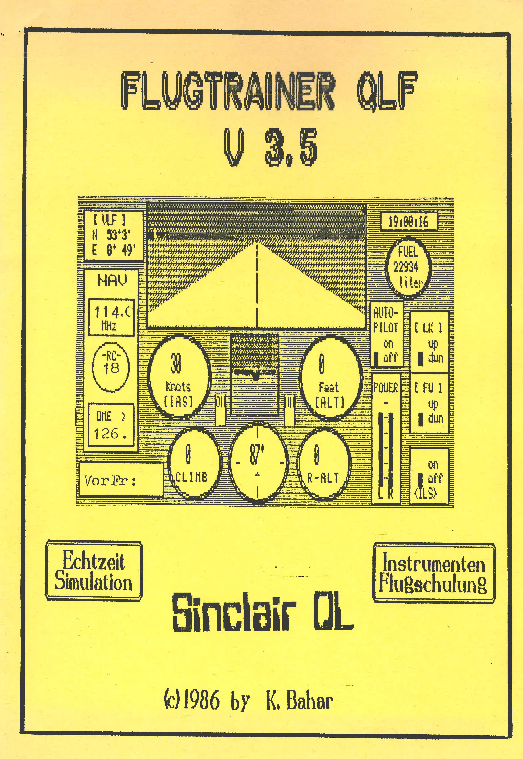

This programme simulates a medium distance airliner of the type "DC-9". With this flight simulator the single flight manoeuvres and concurrent supervising of all aircraft instruments can be practiced. Actions always have an effect with a delay. Nevertheless, this corresponds to the slow reaction of a typical scheduled plane. In order to carry out a complete flight training is necessary.

At the beginning of the program the start airport (10 freely for the choice) by means of the suitable figure key will stand selected. With the key <F5> it is possible to coach the difficult landing approach.
Now, however, to the takeoff: The airplane stands with delivered landing flaps and engines in the running dry at the beginning of the runway. As the first increas the thrust "power" to the maximum. You must keep an eye on the compass permanently and correct every deviation by side hoist immediately. If the speed from 178 to 175 knots is achieved, the airplane can take off by a single press of the cursor up key. Besides, the machine lifts "nose" automatically about 6 degrees upwards and starts to climb up at the same time. Now the chassis should be run. The landing flaps must be also run between 200 and 250 knots.

Now one can change according to demand the steep path rate ("Climb"). The travel height of a scheduled plane amounts to from 10,000 to 40,000 feet (according to distance of the airport of destination). The thrust has to go after achievement of the cruising speed of 500 knots am reduced en. With short distances a maximum speed should be aimed by about 350 knots. In the beginning the „autopilot" should be also switched on. This automatically corrects all health resort sound height changes which are caused by height hoist.
The instrumental flight happens if the view contact does not exist any more (dense cloud cover, night flight). Now the realisation of the flight schedule it is possible only about the aircraft instruments. "Artificial horizon“ indicates the situation of the machine to the horizont, while the compass gives among them the direction in which the airplane moves. Now it is aimed with the help of the navigation instruments the airport of destination or another close station. \"pre-frequency \" is given with the key <V>. Shortly after the radiocompass \"R-C \" indicates(signalises) the direction in which one must straighten the machine. \"DME \" delivers(supplies) other(farther) important information.

It indicates permanently the distance between airplane and the aimed pre-station. Moreover, a signal lights up, if the machine of the station approaches. If it(she) is removed herself from it a short line indicated . The NAV instruments can be out of order in two cases: if no station was saimed, or if the station is still more than 300 miles away.

For the landing two important instruments are required: the altimetre („OLD \") registers elativ to the sea level. Therefore, it is used with the landing of the height radar (\"R old \"), because this indicates(signalises) the exact(precise) height of the machine. This is the second instrument(tool) \"the ILS crosshair \" which appears after the turning on in the artificial horizon(skyline). The flight occurs(takes place) at a speed of from about 190 to 220 knots and by a height between 1700 and 2000 foot. If one has reached(achieved) \"out marker point \" ("OM"), there flashes(winks) the OM light. As soon as this has happened, one must steer the machine in runway direction.
In addition one must know the land road Radial of the airport of destination (see list of the airports). If the right course(price) is put(stopped) and the ILS system in the switched on state(condition), appears the crosshair. To hold the airplane on the ILS-Gleitweg, the cross must be brought by constant course corrections in a middle position. After Blink \"of Middle marker \" ("MM") the land measures must be initiated immediately. As soon as the radar height of about 60 feet has been fell short, one must bring the machine in the level(horizontal) (tip: 3 times key Cursor-up operate). If the machine has touched the ground, the push(thrust) must be completely taken back. The brakes are drawn(dressed) by low-spirited holds <B> key.

Kazim Bahar
(Orignal in German, translated by Detlef Obermann)

